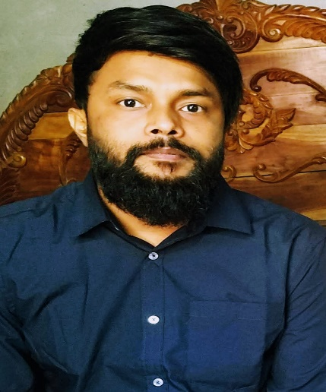Resume of

**MD. ROKUNUZZAMAN ROKON**

* Cell: +8801739-933258
* E-mail: rokon.raz@gmail.com
* LinkedIn: linkedin.com/in/rokon-raz
* Facebook: facebook.com/rokon.raz/
* GitHub: https://github.com/RoknuzzamanRokon

**Career Objective**

To obtain a software developer position in a fun, fast-paced, cutting-edge environment that promotes teamwork and integrity and fosters personal and professional development.

**Work History**

1. (2022-2023) Worked for 4 months as HR executive and sir flit executive in the e-commerce company.

**2.** (2018-2022) I have been working in KFC for 5 years besides study.

**3.** (2012-1-2017) I have done many types of jobs. I have worked in such places as world division survey, auto spinning mill, EPZ camera making company, Prince Bazar store assistant, etc.

**Learning History and Project**

**1.** Learning programming languages while I work, C, HTML, CSS, JavaScript, MySQL are known little, Python, Django, React etc.

**2.** I can learn many machines with Python, such as coffee machines, digital clocks, snack games, blackjack, and many more. Also, there are more projects of this type like Hangman, High Low, Auction, Ceasercaiper, Guess Number I know a lot about this type. I also work with API.

**3.** ”Automation of entering the restaurant and POS machine operation Using Face Recognition” (Python base)This is my thesis paper. I was doing this project at university.

**My Wish**

I want to do something with machine learning. I have an idea of 1 new machine, if this is developed, the money transactions of many businesses will become much easier.

**Education**

European University of Bangladesh 2022

B.Sc. (Hons.) in Computer science & Engineering

GPA: 3.26/ 4

Birampur College, Dinajpur 2014

H.S.C: GPA: 3.30/ 5 (Science)

Adarsha High School, Dinajpur 2012

S.S.C: GPA: 4.44/ 5 (Science)

**Software Skill**

Microsoft Word, Microsoft Excel, Microsoft PowerPoint, Windows Operating System, Linux Operating System, Pycharm, VS code, Juypter Notebook, Code Block, VirtualBox, EverNote etc.

**Language Proficiency**

Bengali- Mother Tongue

English- Working Proficiency

**Personal information**

Name : Md. Rokunuzzaman Rokon

Father's Name : Md. Abu Bakar Siddik

Mother's Name : Mst. Roksana Begum

Date of Birth : 18 June, 1995

Gender : Male

Marital Status : Unmarried

Religion : Islam

Nationality : Bangladeshi

Home District : Dinajpur

**Declaration**

I hereby declare that the information provided in this CV in strictly maintained to that best of my memory.

Sincerely,

………………………………

**Md. Rokunuzzaman Rokon**

Date: